🏫 SCHOOL ERP SYSTEM
📘 FULL PROJECT DOCUMENTATION (CONTINUOUS CHAPTER REPORT)

📌 CHAPTER ONE: INTRODUCTION
1.1 Introduction to the Chapter
This chapter introduces the School ERP System, a comprehensive digital platform designed to manage all academic, financial, administrative, transport, examination, and communication activities within a school environment. It outlines the background of the study, existing systems, problem statement, proposed solution, objectives, justification, scope, limitations, significance, and operational definitions of terms.
The system is designed to replace fragmented manual school processes with a centralized, secure, and automated digital ecosystem that supports real-time data flow, role-based access control, and decision-making.

1.2 Background of the Study
Education institutions have traditionally relied on manual processes such as paper-based attendance registers, physical fee records, manual result compilation, and informal communication channels. With the introduction of Competency-Based Curriculum (CBC), schools require more structured, data-driven systems to track student progress, manage diverse learning pathways, and ensure accountability across departments.
The increasing number of students, complexity of academic structures (ECD, Lower Primary, and Junior Secondary School), and financial management demands have created a need for an integrated system that connects all stakeholders including students, teachers, administrators, finance officers, examination officers, and institutional departments.

1.3 Current/Existing System
Most schools currently use semi-manual or partially digital systems such as:
- Excel sheets for fees and results
- Paper-based attendance registers
- Separate standalone software for exams or accounting
- Manual timetable creation
- Physical communication notices
These systems operate independently and lack integration, leading to inefficiency, duplication of work, poor coordination, and data inconsistency.

1.4 Problem Statement
The existing systems in schools suffer from several challenges:
- Lack of integration between academic, financial, and administrative data
- High risk of human error in results and fee tracking
- Difficulty in generating real-time reports
- Inefficient communication between departments
- Weak audit and accountability systems
- No centralized control for school operations
These problems make school management slow, error-prone, insecure, and difficult to scale under CBC requirements.

1.5 Proposed System
The proposed CBC School ERP System is a centralized, role-based platform that integrates all school operations into one system. It provides:
- Automated student registration with system-generated admission numbers
- Role-based dashboards for all users (Admin, Teacher, Student, Finance Officer, Examination Officer, Librarian)
- Secure authentication system:
  - Username based on admission number (students) and staff ID (workers)
  - Auto-generated passwords
  - SMS delivery of login credentials
  - OTP-based password reset and verification
- User profile management system:
  - Passport photo upload during registration
  - Profile page displaying user details
  - Editable fields (email, phone number)
  - Secure password update using OTP
- Teacher role-based system:
  - A teacher can have multiple roles (e.g., subject teacher, class teacher, HOD, deputy, headteacher)
  - Roles are assigned by the admin and reflected dynamically on the teacher dashboard
- Academic system:
  - Marks entry by teachers (opener, midterm, end-term)
  - Automatic grading based on grading system defined by the Examination Officer
  - Result aggregation and processing handled by the Examination Office
  - Generation of report forms and exam cards
- Finance module:
  - Fee structure setup per class and term
  - M-Pesa payment integration (STK push)
  - Receipt generation
  - Handling of overpayments, refunds, and student-to-student transfers with OTP approval
  - Financial reports and analytics
- Examination system:
  - Examination Officer defines grading system and pass marks
  - Receives marks from teachers and processes results
  - Generates reports per student, class, grade, subject, and year
  - Publishes approved results to students
- Library management system:
  - Book registration and categorization
  - Borrowing and return tracking
  - Fine calculation
- Notification system:
  - In-app notifications (bell icon)
  - SMS alerts for important actions (login, payments, results)
- Administrative reporting:
  - Admin can generate reports across all modules (read-only, based on data from respective departments)
- Audit system:
  - Tracks all system activities
  - Logs cannot be edited
The system ensures seamless interaction between all departments while maintaining security, accountability, and data integrity.

1.6 General Objective
To design and implement a centralized, secure, and automated School ERP system that integrates academic, financial, administrative, and institutional operations in CBC-based institutions.

1.7 Specific Objectives
- To design a role-based authentication system for all school users.
- To develop an automated academic system for marks entry, grading, and result aggregation.
- To implement a financial management system including fee tracking, digital payments, refunds, and transfers.
- To develop an integrated communication system using SMS and in-app notifications.

1.8 Justification of the Study
The system is justified by the need to:
- Improve efficiency in school operations
- Reduce manual errors in academic and financial data
- Enhance transparency and accountability
- Support CBC education structure
- Provide real-time data access for decision-making

1.9 Scope of the Study
The system covers:
- Students, teachers, and administrative staff
- Finance and examination departments
- Library system and academic management
- Academic tracking from ECD to JSS
- Fee management, payments, and reporting
- Result processing, grading, and analytics
- User authentication and profile management

1.10 Limitations of the Study
- Requires internet connectivity for full functionality
- Dependence on SMS gateway services for communication
- Initial setup complexity for institutions
- Requires user training for adoption
- High system dependency on accurate data entry

1.11 Significance of the Study
The system benefits:
- Schools: centralized management and operational efficiency
- Teachers: simplified academic tracking and reporting
- Students: access to results, profiles, and financial records
- Parents: improved transparency
- Administrators: enhanced decision-making capabilities
- Government/Policy makers: improved education data tracking

1.12 Operational Definition of Terms
- ERP: Enterprise Resource Planning system for school management
- CBC: Competency-Based Curriculum
- Admission Number: Unique student identifier
- Staff ID: Unique identifier for school employees
- HOD: Head of Department
- OTP: One-Time Password for verification
- Grade: Academic level classification
- Audit Log: System record of all activities

1.13 Related Literature Review
- School Management Systems (SMS) – Provide basic student and fee management but lack deep integration.
- Open-source ERP systems – Offer modular systems but are not CBC-specific.
- Moodle LMS – Focuses on learning but lacks financial and administrative modules.
- SIS Systems (Student Information Systems) – Manage academic data but lack full ERP integration.
- Commercial ERP systems (e.g., SAP Education) – Powerful but expensive and not tailored for local school environments.

1.14 Gaps/Lacunas
- Lack of CBC-specific ERP systems
- Poor integration of finance, academics, and administration
- Limited automation in grading and result processing
- Weak support for multi-role teacher structures
- No unified communication system combining SMS and in-app alerts

1.15 Context Diagram / Conceptual Framework
The system consists of the following key actors:
- Admin (Central Controller)
- Teachers (Academic Input and Role-Based Operations)
- Students (System Output Consumers)
- Finance Officer (Financial Processing and Reporting)
- Examination Officer (Result Processing and Academic Control)
- Librarian (Library Operations)
All users interact with a centralized system which performs validation, processing, and storage of data in a unified database. The system distributes processed information through role-based dashboards and communicates updates via notifications and SMS alerts.

1.16 Chapter Conclusion
This chapter has presented the foundation of the CBC School ERP System, highlighting existing challenges in school management and proposing a fully integrated, role-based solution that ensures efficiency, accountability, and scalability.

📌 CHAPTER TWO: DEVELOPMENT METHODOLOGY
2.1 Introduction
This chapter explains the methodology used to design and develop the system, including system analysis, design approach, implementation strategy, and system workflow representation.

2.2 Development Methodology
The system will use the Agile Development Methodology.

2.3 Justification of Methodology
Agile is chosen because:
- It supports iterative development
- Allows continuous improvement
- Enables early testing and feedback
- Handles complex systems with multiple modules

2.4 Data Analysis
The system will use:
- Relational data modeling using MySQL
- Role-based data segmentation
- Transaction-based financial data tracking
- Time-series academic performance analysis
- Audit log analysis for system transparency

2.5 System Flowcharts
General System Flow

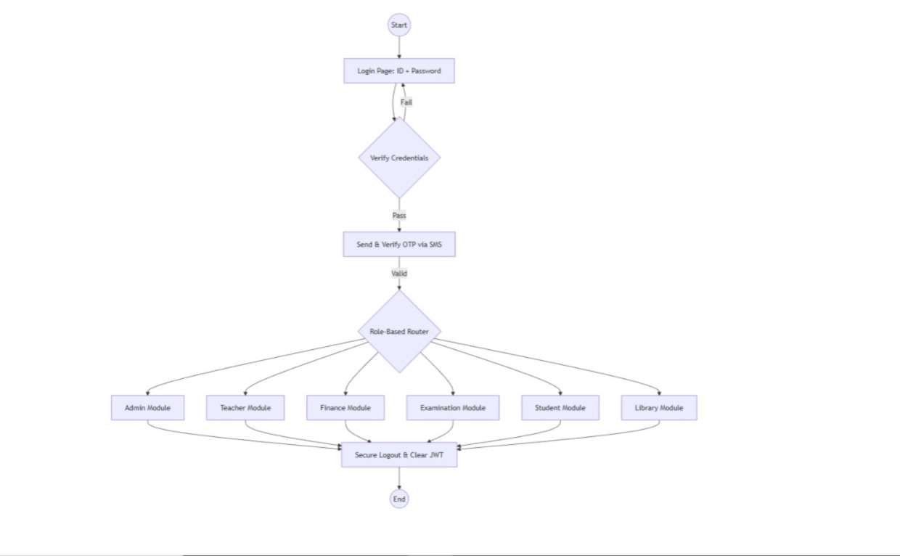
Start
↓
User Login
↓
Authentication (Username + Password)
↓
OTP Verification (if required)
↓
Role Detection
↓
Dashboard Access Granted
↓
User Selects Operation
↓
System Validates Input
↓
Database Processing (Insert / Update / Retrieve)
↓
Trigger Notification (SMS / System Alert)
↓
Audit Log Recorded
↓
End

Admin Flow

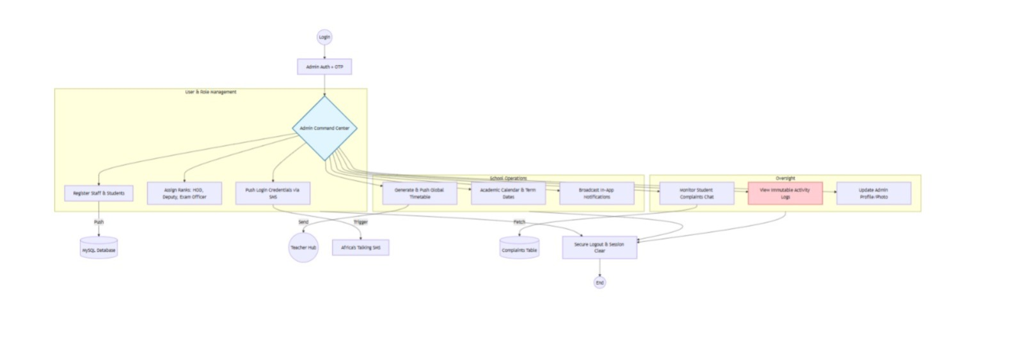
Start
↓
Login
↓
Access Admin Dashboard
↓
Select Function
↓
(User Management / Timetable / Reports / Communication)
↓
Perform Action
↓
System Validation
↓
Database Update or Data Retrieval
↓
Generate Report (if selected)
↓
Send Notification (if required)
↓
Log Activity
↓
End

Teacher Flow
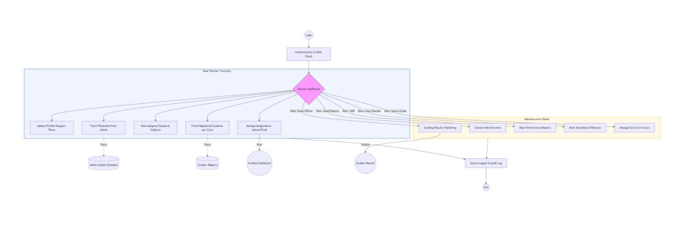

Start
↓
Login
↓
Load Assigned Roles
↓
Select Task
↓
(Enter Marks / Attendance / View Performance)
↓
Submit Data
↓
System Validates
↓
Store Data
↓
Forward to Examination Office
↓
Log Activity
↓
End

Student Flow
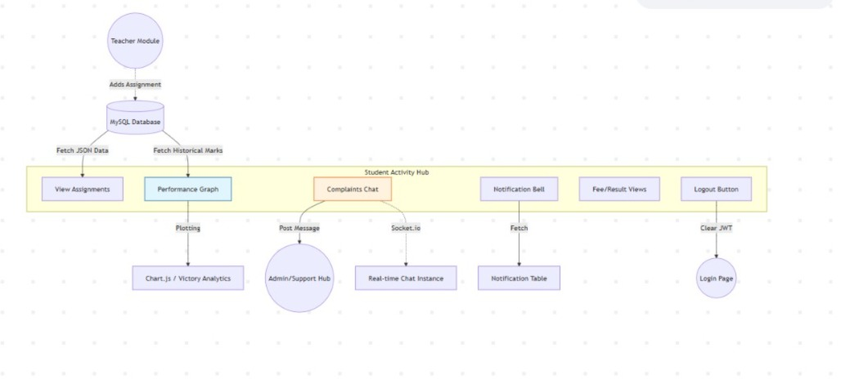
Start
↓
Login
↓
Access Dashboard
↓
Select Service
↓
(View Results / Fees / Profile)
↓
System Validation
↓
Display Data
↓
Generate Document (if requested)
↓
End

Finance Flow
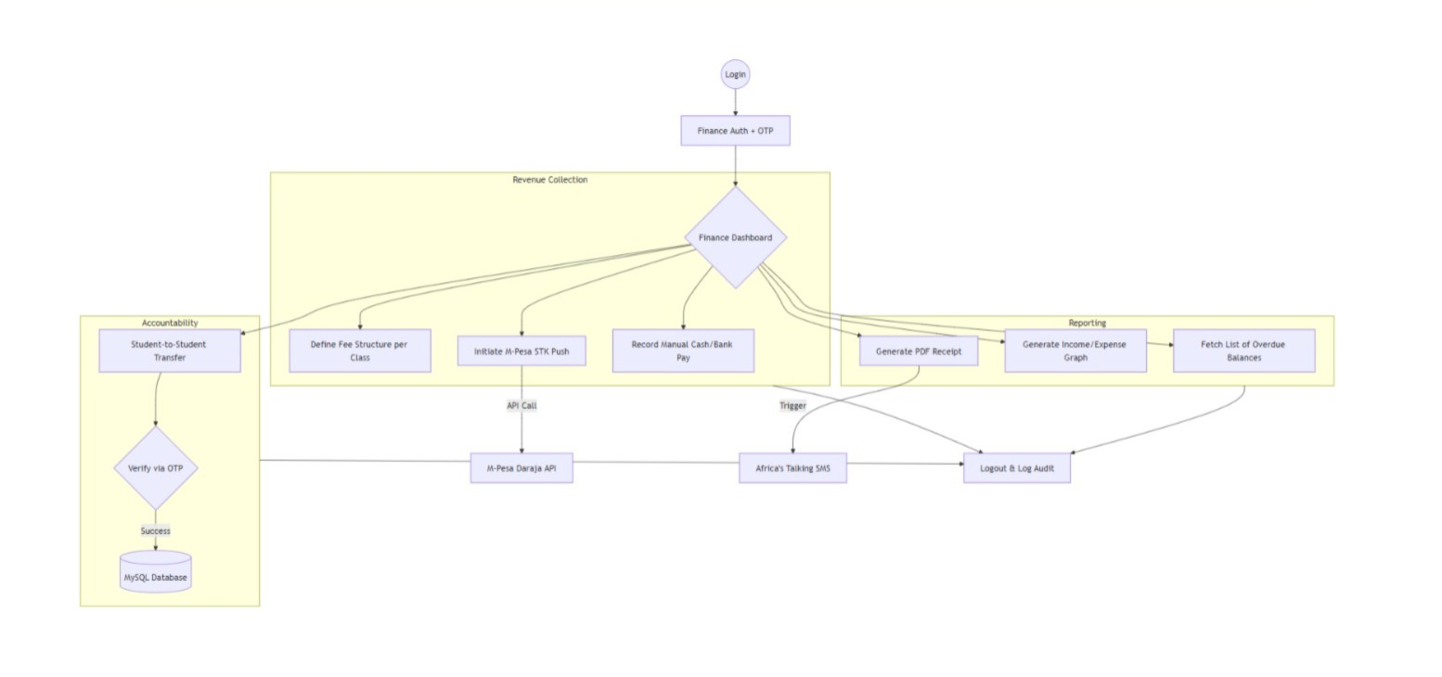
Start
↓
Receive Payment (M-Pesa / Manual Entry)
↓
Verify Transaction
↓
Update Student Account
↓
Generate Receipt
↓
Store Transaction Record
↓
Send Notification (SMS)
↓
End

Examination Office Flow
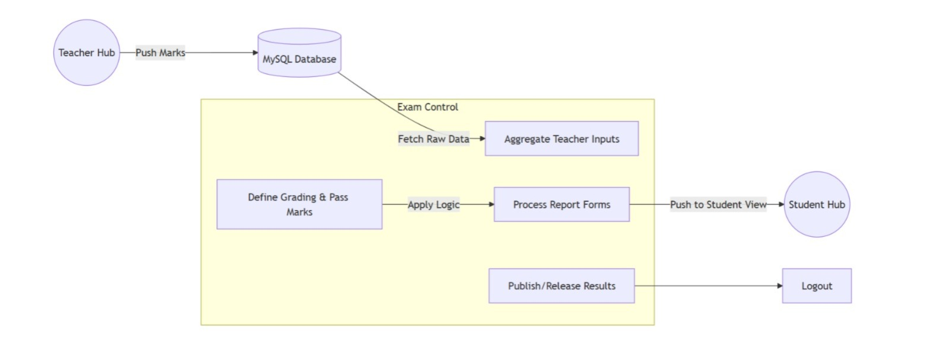
Start
↓
Receive Marks from Teachers
↓
Aggregate Results per Student
↓
Apply Grading System
↓
Compute Final Scores
↓
Review Results
↓
Approve Results
↓
Publish Results
↓
End

Library
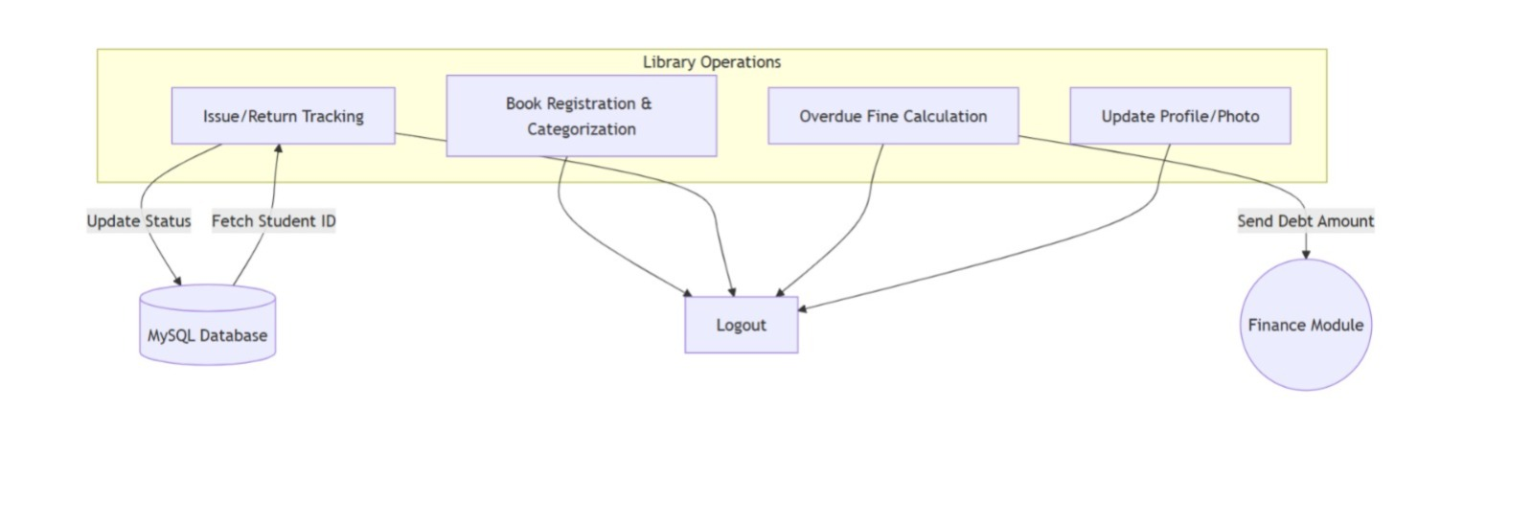

2.6 Chapter Conclusion
This chapter outlines the Agile methodology and defines the system workflows, ensuring a structured approach to system development and implementation.

📌 CHAPTER THREE: SYSTEM ARCHITECTURE AND TECHNOLOGY STACK
3.1 Introduction
This chapter describes the system architecture and the technologies used in the development of the CBC School ERP System.

3.2 System Architecture
The system follows a three-tier architecture:
- Presentation Layer (Frontend)
- Application Layer (Backend)
- Data Layer (Database)
This structure ensures scalability, maintainability, and security.

3.3 Technology Stack

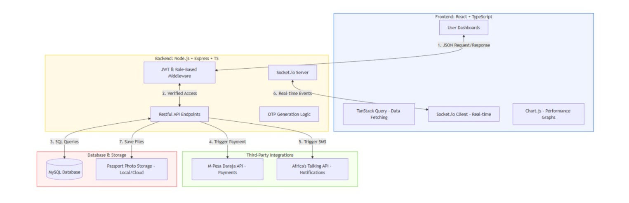
Frontend Technologies
The system will use React with TypeScript to build interactive and responsive user interfaces. This allows for efficient development of role-based dashboards and reusable components.

Backend Technologies
The backend will be developed using Node.js with TypeScript, which provides a scalable environment for handling multiple concurrent users, API development, authentication, and system logic processing.

Database
The system will use MySQL as a relational database to manage structured data such as students, teachers, results, and financial transactions.

SMS Integration
The system will integrate with an SMS gateway (such as Africa’s Talking API) to send:
- Login credentials
- OTP verification codes
- System notifications

Payment Integration
The system will use M-Pesa STK Push for processing school fee payments securely and in real time.

Real-Time Communication
Socket.io will be used to implement real-time notifications and system updates within dashboards.

File Storage
The system will store passport photos and documents in a file storage system, with file paths referenced in the database.

Security Mechanisms
The system will implement:
- Password hashing
- OTP-based authentication
- Role-based access control
- Audit logging

3.4 Justification of Technology
The selected technologies provide:
- High performance and scalability
- Strong security mechanisms
- Efficient handling of relational data
- Support for real-time communication
- Compatibility with modern web development standards

3.5 Chapter Conclusion
This chapter has outlined the system architecture and the technologies that will be used to implement the CBC School ERP System, ensuring a secure, scalable, and efficient solution.

📌 FINAL CHAPTER CONCLUSION (OVERALL)
The CBC School ERP System is a fully integrated institutional management platform designed to handle all aspects of school operations including academics, finance, communication, examination, and administration. It introduces automation, accountability, and centralized control, making it a scalable and reliable solution for modern CBC institutions.

